[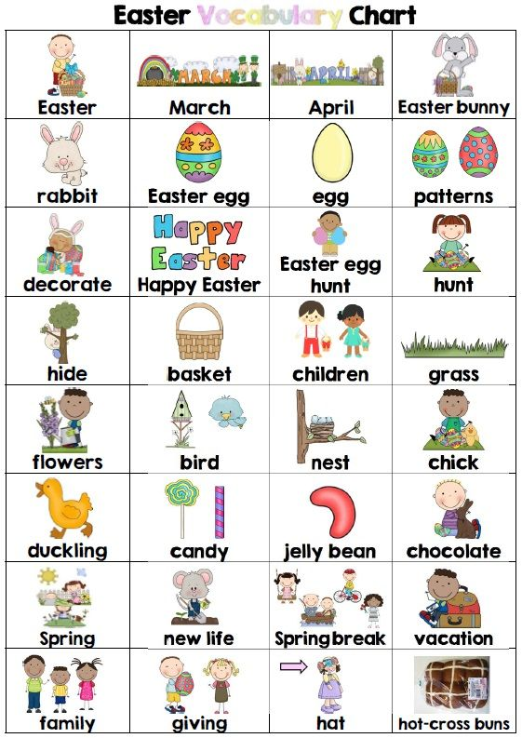](https://www.google.pl/url?sa=i&url=https%3A%2F%2Fwww.wellingtonhousebcn.com%2F2018%2F03%2Feaster-vocabulary-for-english-students-esltefl%2F&psig=AOvVaw1L_hMyLI59o1YOKzIGVRje&ust=1586240599973000&source=images&cd=vfe&ved=0CAIQjRxqFwoTCND05-yU0-gCFQAAAAAdAAAAABAe)