Domáca úloha zo Slovenského jazyka a literatúry

od 1. 3. 2021 do 5. 3. 2021

Meno žiaka:

Ročník: tretí

Vypracovala: Mgr. Iveta Rudyová

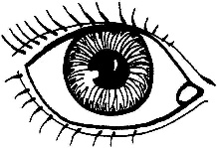Čítaj:

**O**KO

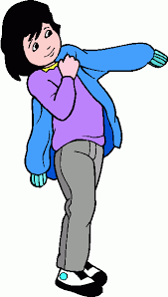

**O**BLIEKAŤ

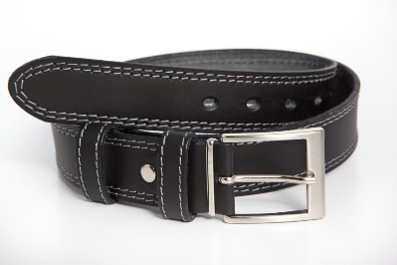

**O**PASOK

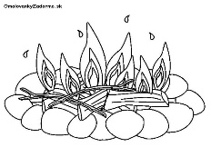

**O**HEŇ

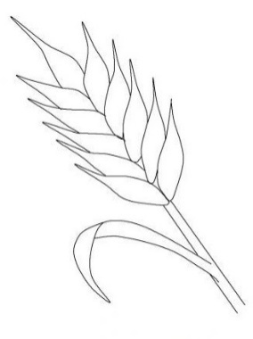

**O**BILIE

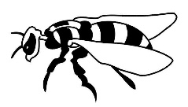

**O**SA

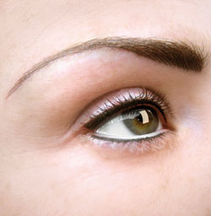

**O**BOČIE

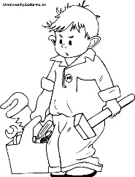

**O**PRAVÁR

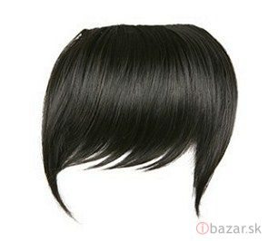

**O**FINA

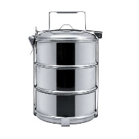

**O**BEDÁR



**O**BJAŤ

Nalep písmeno o:

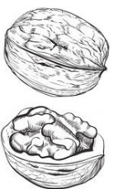



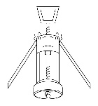

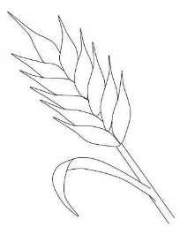

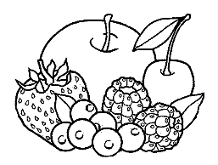

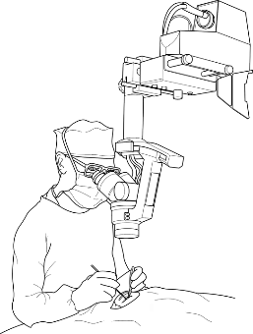

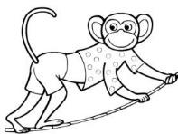

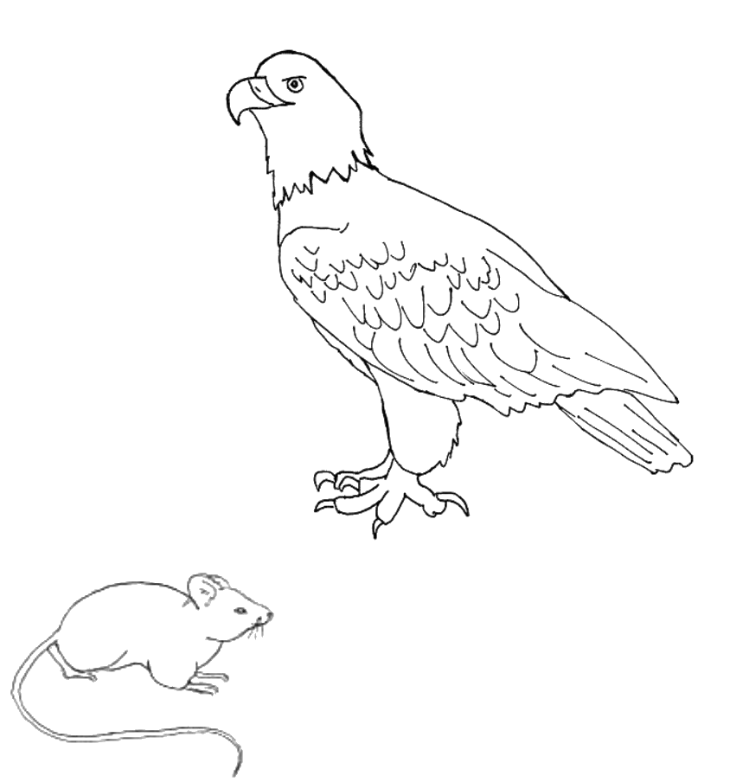

Vystrihni písmeno O:

|  |  |  |  |  |  |  |  |
| --- | --- | --- | --- | --- | --- | --- | --- |
| O | O | O | O | O | O | O | O |
| O | O | O | O | O | O | O | O |
| O | O | O | O | O | O | O | O |
| O | O | O | O | O | O | O | O |
| O | O | O | O | O | O | O | O |
| O | O | O | O | O | O | O | O |
| O | O | O | O | O | O | O | O |

|  |  |  |  |  |
| --- | --- | --- | --- | --- |
| u | J | e | M | v |
| a | A | V | i | I |
| V | i | P | p | V |
| v | m | U | u | v |
| m | L | E | V | O |
| o | V | m | i | o |
| P | O | v | L | V |
| v | o | l | V | v |
| O | M | a | A | I |
| a | l | V | v | u |
| V | v | J | j | O |
| O | v | i | U | a |
| M | m | e | a | i |
| v | v | E | V | V |
| O | I | A | U | M |

Nájdi písmená V,v a vyfarbi ich modrou farbičkou: