Meno žiaka:
Trieda:

Slovenský jazyk od 25. 1. do 29. 1. 2021

Vypracovala: Mgr. Silvia Dikejová
Prepíš tlačené písmená na písané:
Z | ch | B | f | r | N | Š | Ž
U | G | h | Ď | t | g | Ň | k
C | r | ch | N | Ž | v | f | Ť
D | b | k | p | E | z | i | h

Čítaj:

Gabika a Gitka sa hrali s gumenou loptou. Starý otec fúkal do fujary. Fedor a mama sedeli v kuchyni. Na stole boli orechy. V chladničke boli dva jogurty.

Prečítaj nahlas a zakrúžkuj písmená F, f:
Zafarbil si Fero fúzy,
farbami od tety Zuzy.
Nafarbil si Fero pruhy,
fúzy má vo farbách dúhy.

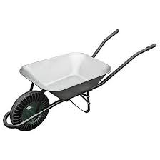
Pomenuj obrázok. Slovo napíš pod obrázok na linajku:

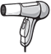
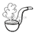
___________________________________________________________________________
....................................................................................................................................................___________________________________________________________________________

Vety prepíš písaným písmom:
Filmár nafilmoval film.
___________________________________________________________________________
....................................................................................................................................................___________________________________________________________________________
Ujo Filip má obrovskú fajku.
___________________________________________________________________________
.....................................................................................................................................................___________________________________________________________________________

Profesor hrá na flautu a harfu.
___________________________________________________________________________
.....................................................................................................................................................___________________________________________________________________________
Precvič si písanie písmen.
___________________________________________________________________________
.....................................................................................................................................................___________________________________________________________________________
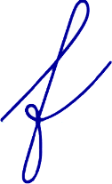
___________________________________________________________________________
.....................................................................................................................................................___________________________________________________________________________

Prečítaj a potom prepíš slová na písané:

jogurt |  | orgován
kufor |  | chlieb
Ferdo |  | fúkať
regál |  | tiger
gunár |  | guma
gága |  | orech

Zakrúžkuj písmená G, g: Gúľa Gusto guľôčku,
zagúľal ju k potôčku.
Zgúľala sa do vodičky,
už je Gusto bez guličky.

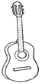
Pomenuj obrázok. Slovo napíš pod obrázok na linajku.
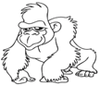

___________________________________________________________________________
.....................................................................................................................................................___________________________________________________________________________

Vety prepíš písaným písmom:

Ujo Gregor gituje obloky.
___________________________________________________________________________
.....................................................................................................................................................___________________________________________________________________________
Gitka hrá na gitare.
___________________________________________________________________________
.....................................................................................................................................................___________________________________________________________________________
Gusto strelil pekný gól.
___________________________________________________________________________
.....................................................................................................................................................___________________________________________________________________________

Precvič si písanie:
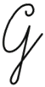
___________________________________________________________________________
.....................................................................................................................................................___________________________________________________________________________
___________________________________________________________________________
.....................................................................................................................................................___________________________________________________________________________

Prečítaj slová a prepíš na písané:

rieka |  | Gabika
chrúst |  | Gizka
krieda |  | fúra
fúrik |  | kefa
trieda |  | fúkať
tiger |  | fujara
kuchyňa |  | gól

